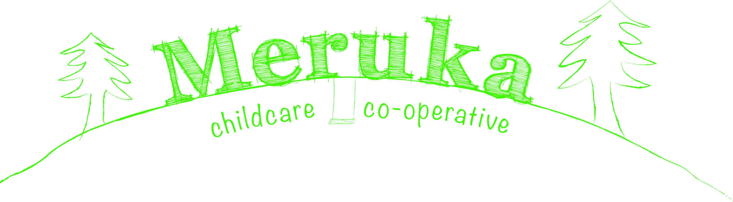
Programming Policy
Programme planning, learning and development and evaluation
The qualified educator in charge of the 0-2 room and the 2-3 room, and the kindergarten teacher in the 3-5 room, in association with the other Educators is responsible for planning and implementing an Early Childhood Programme in accordance with the Early Years Learning Framework.
This programme is designed to reflect child centred, play based anti-biased and multi-cultural experiences. It aims to be developmentally and age appropriate and emerge from the children’s observed interests, along with information provided by families regarding children’s interests, experiences and routines. Educators observe children across the day, recording their observations and use them to modify and develop the programme as required thus also incorporating age appropriate Intentional Teaching to further extend each child’s individual development.

Victorian Early Years Learning Framework
The Victorian Early Years Learning and Development Framework, is a document developed by the Department of Education and Early Childhood Development in partnership with the Victorian Curriculum and Assessment Authority. This advances all children’s learning and development from birth to eight years. It does this by supporting all early childhood professionals to work together and with families to achieve common outcomes for all children.
The framework has been developed to encourage play, fun and enjoyment through learning. Early childhood professionals recognise that learning is an active process that must involve children’s engagement and interactions with adults and peers to support children’s learning and development. Play is essential to stimulate and integrate a wide range of children’s intellectual, physical, social and creative abilities.
The frame work identifies eight practice principles for learning and development which are broken down into three categories;
Collaborative
- Family cantered practices
- Partnerships with professionals
- High expectations for every child
Effective
- Equity and diversity
- Respectful relationships and responsive engagement
- Integrated teaching and learning approaches
- Assessment for learning and development
Reflective Practice
- Reflective practice
From these principles the framework has developed five learning outcomes that we will relate our planning and children’s development to.

The five learning outcomes are:
- Children have a strong sense of identity
In order to form strong sense of self, children need to build secure relationships first with their family and then with caring attentive educators.
- Children are connected with and contribute to their world
Through opportunities and support children learn to connect and participate with their peers. Participating in their community’s strengths a child’s sense of identity and wellbeing.
- Children have a strong sense of wellbeing
During early childhood the foundations of social, emotional and spiritual wellbeing are laid. While in care the child will learn to take responsibility for their own health and physical wellbeing.
- Children are confident and involved learners
When babies and young children are relaxed and involved in a stimulating programme they can explore, express wonder and interest in their environment. When they are encouraged and supported to be curious and enthusiastic participants in learning, they begin to develop postie dispositions for lifelong learning.
- Children are effective communicators
Children communicate from birth. Through non-verbal and verbal communication children learn to communicate their needs and wants for general wellbeing. Maintenance of first language is important for children’s identity, wellbeing, communication and learning.

Documents and implementation
Educators within each room take regular group and individual observations on the children over the course of each year. A variety of documentation will be used to gather information about the children’s learning, development and interests, including information provided by families. Each child will have their own portfolio where all their observations and documentation will be collected. Children’s portfolios will be kept in their room, and will be available for parents to view and contribute information towards. Parents are encouraged to take their child’s portfolio home, and are notified in writing when a new observation is placed in their child’s portfolio. A family voice section will be placed with each observation taken on the children for the parents to provide feedback on and also assist educators in future programming to further develop children’s learning.
Children’s portfolios will be handed to parents to take home upon their child’s completion of the service. Parents are encouraged upon arrival at the centre to communicate information about their child’s interests, needs, routine leaning and experiences. Children are encouraged to view their own port folio and share with educators and friends. A parent input book has been implemented in each room for the families to document any interests, experiences, holidays, places of interest they may visit, this will allow educators to have a better understanding and gain more knowledge of each child’s family’s interests outside the Meruka community, thus extending educators programming. Staff will endeavour to document important verbal information provided by families. Background sheets are also sent out to families to gather further information on each child to assist Educators in helping provide a sense of belonging in the service and plan for them better. Parent – Educator interviews and written reports are conducted once a year to allow families time to sit down and discuss and concerns or information on their child in a relaxed environment.
Each room has evidence of the Early Years Learning Framework and permanent play spaces, depicting the importance of learning through play. Each room will display a Weekly Journal where educators will document children’s interest, spontaneous play and group activities, also allowing a space for Family Voice, this in turn will be reflected on. Each of the room will have a plan on the wall that will show what experiences are set up and any modifications that have been made.

Set up activities based on interests, age appropriate development and goals.
Plan Observe

Document learning observed then relate to outcomes and practice principles and reflect on further possibilities
Document the observed learning, Reflect/ Analyse
The planning Cycle

Modify and extend activity to further extend child’s learning
Review Extend

Individual Observations: Educators will endeavour to obtain an observation on new children at the centre within their first 3 weeks of care; however Educators priorities will be to ensure that all new children form meaningful relationships with educators and help settle into the environment to help promote their sense of belonging. Educators will take a variety of meaningful observations on the children over the course of the year. Each child’s learning is individual and spontaneous. Individual observations will be documented, then reflected on, modifications are made, thus further extending their learning and development, then reviewed and related to the Early Years Learning Framework. We aim to document and follow their learning journey making modifications when necessary. These modifications will also govern what is planned in the room.
Group Observations: Educators will take meaningful observations of the group over the course of the year. This will include learning that the children have experienced from the activities, how it relates to the Early Years Learning Framework and forward planning.
Throughout the group observations Educators will analyse the learning happening throughout the activities and make assessments as to further learning and extensions to activities. Group observations will show connections to the Early Years Learning Frameworks and/or Practice Principles. All observations will be reviewed and added to if necessary.
Weekly Reflections: Educators will reflect on the children’s interests and learning. Educators will write regular reflections on individuals and the group from seen interests and learning. We aim to document and follow their learning journey, making any modifications and adding new interest.
Information to share with families: Educators will place useful information sheets and interesting articles for families to view in the parent pockets and parent input book.

Referenced National Quality Standards

- Quality Area 1.1 – An approved learning framework informs the development of a curriculum that enhances each child’s learning and development.
  - 1.1.1 Curriculum decision making contributes to each child’s learning and development outcomes in relations to their identity, connection with community, wellbeing, and confidence as learners and effectiveness as communicators.
  - 1.1.2 Each child’s current knowledge, ideas, culture, abilities and interest are the foundation of the program.
  - 1.1.3 The program, including routines, is organised in ways that maximise opportunities for each child’s learning.
  - 1.1.4 The documentation about each child’s program and process is available to families.
  - 1.1.5 Every chills is supported to participate in the program.
  - 1.1.6 Each child’s agency is promoted, enabling them to make choices and decisions and to influence events and their world.

- Quality Area 1.2 – Educators and co-ordinators are focused, active and reflective in designing and delivering the program for each child.
  - 1.2.1 Each child’s learning and development is assessed as part of an ongoing cycle of planning, documenting and evaluation.
  - 1.2.2 Educators respond to children’s ideas and play and use intentional teaching to scaffold and extend each child’s learning.
  - 1.2.3 Critical reflection on children’s learning and development, both as individuals and in groups, is regularly used to implant the program.

- Quality Area 3 – Standards and Elements
  - 3.2.1 Indoor and outdoor spaces are designed and organised to engage every child in quality experiences in both built and natural environments.
  - 3.2.2 Resources, materials and equipment are sufficient in number, organised in ways that ensure appropriate and effective implementation of the program and allow for multiple uses.

- Quality Area 5 – Respectful and equitable relationships are developed and maintained with each child.
- 5.2.1 Each child is supported to work with, learn from and help others through collaborative learning opportunities.

